**PYTHON**

**INCREMENT 1**

**(PNEUMONIA DETECTION THROUGH X-RAY)**

**DUKKIPATI, SRI SAI NITHIN CHOWDARY – (Class Id – 4)**

**INAKOLLU, SRI NAGA BHUVANESHWARI – (Class Id – 9)**

**KOLLURI, NIKHITHA - (Class Id – 12)**

**Project Theme:**

Our project mainly focuses on how to detect pneumonia. So we are trying to build a web application that is easily accessible by the user to use. This website will first asks the user few questions regarding the symptoms of Pneumonia and also will ask them to upload their chest X-ray report, after uploading all the details we will store the data in DB and send them a message whether they should visit a doctor or not. This app is mainly in focus of Hospital Administration.

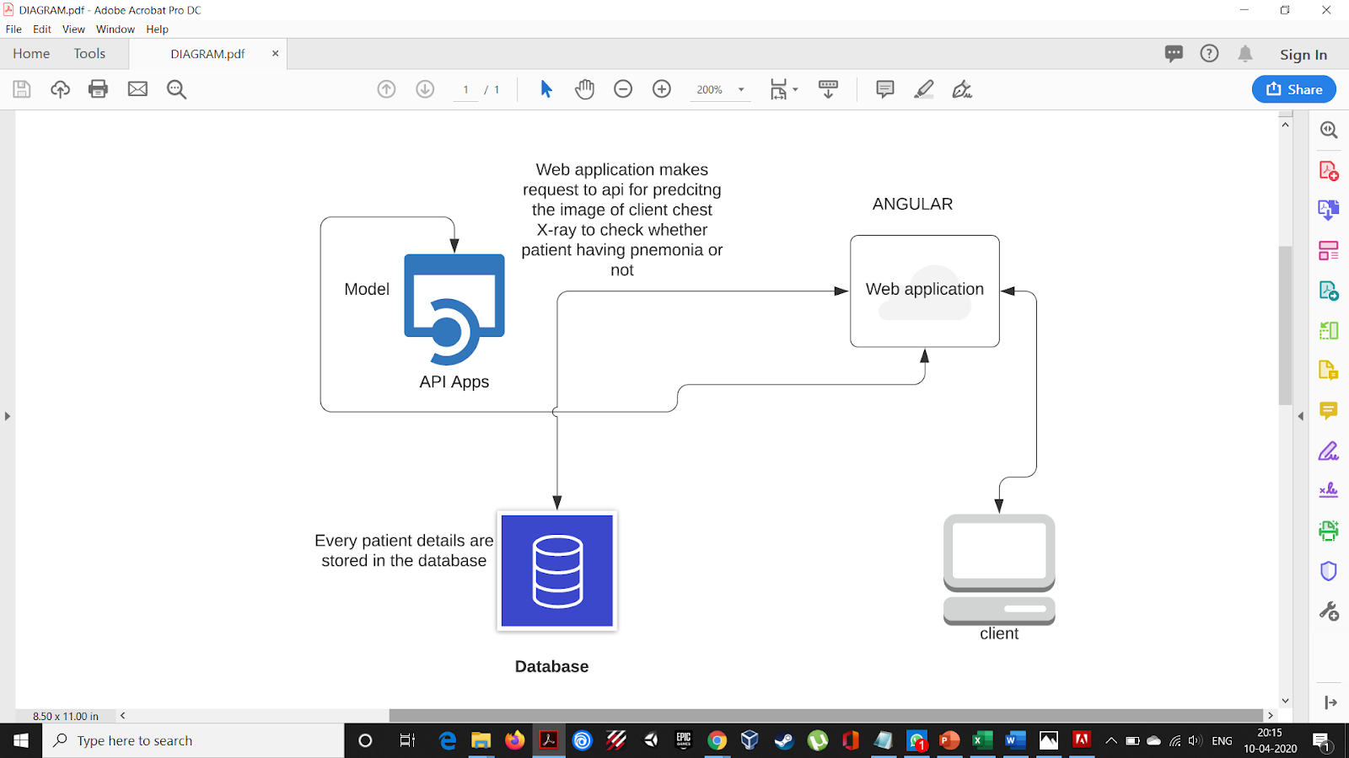

**Project Progress:**

We have built the model with the knowledge we have acquired from the class. We have built a model and got an accuracy of 94%. There is an overfit in our model and we are trying to deal with that as of now. For instance, we are learning a Convolutional neural network and we are also learning how to pre-process the data so that we could fit our model in an efficient way.

**Future Works:**

1. To build a rest API for the model
2. Built a web application using angular
3. Establishing a connection between web application and API

**Team-work:**

DUKKIPATI, SRI SAI NITHIN CHOWDARY – has built the model

INAKOLLU, SRI NAGA BHUVANESHWARI – building the api

KOLLURI, NIKHITHA – worked on pre-processing

**Challenges:**

1. The challenges that we are facing is right now is to reduce overfitting in our model(For this we are trying to learn convolutional neural network)
2. Building a rest API service (we are using flask to build API)

**GitLink:**

You can find our code in the following link

<https://github.com/ntihindukkipati/CS5590_Python_DL>

**Include some pictures for your current progress :**